Name: Ayo B. Vianou

SQL SELECT, WHERE, DISTINCT practice

Write a select statement to return all columns and rows from the customer table. 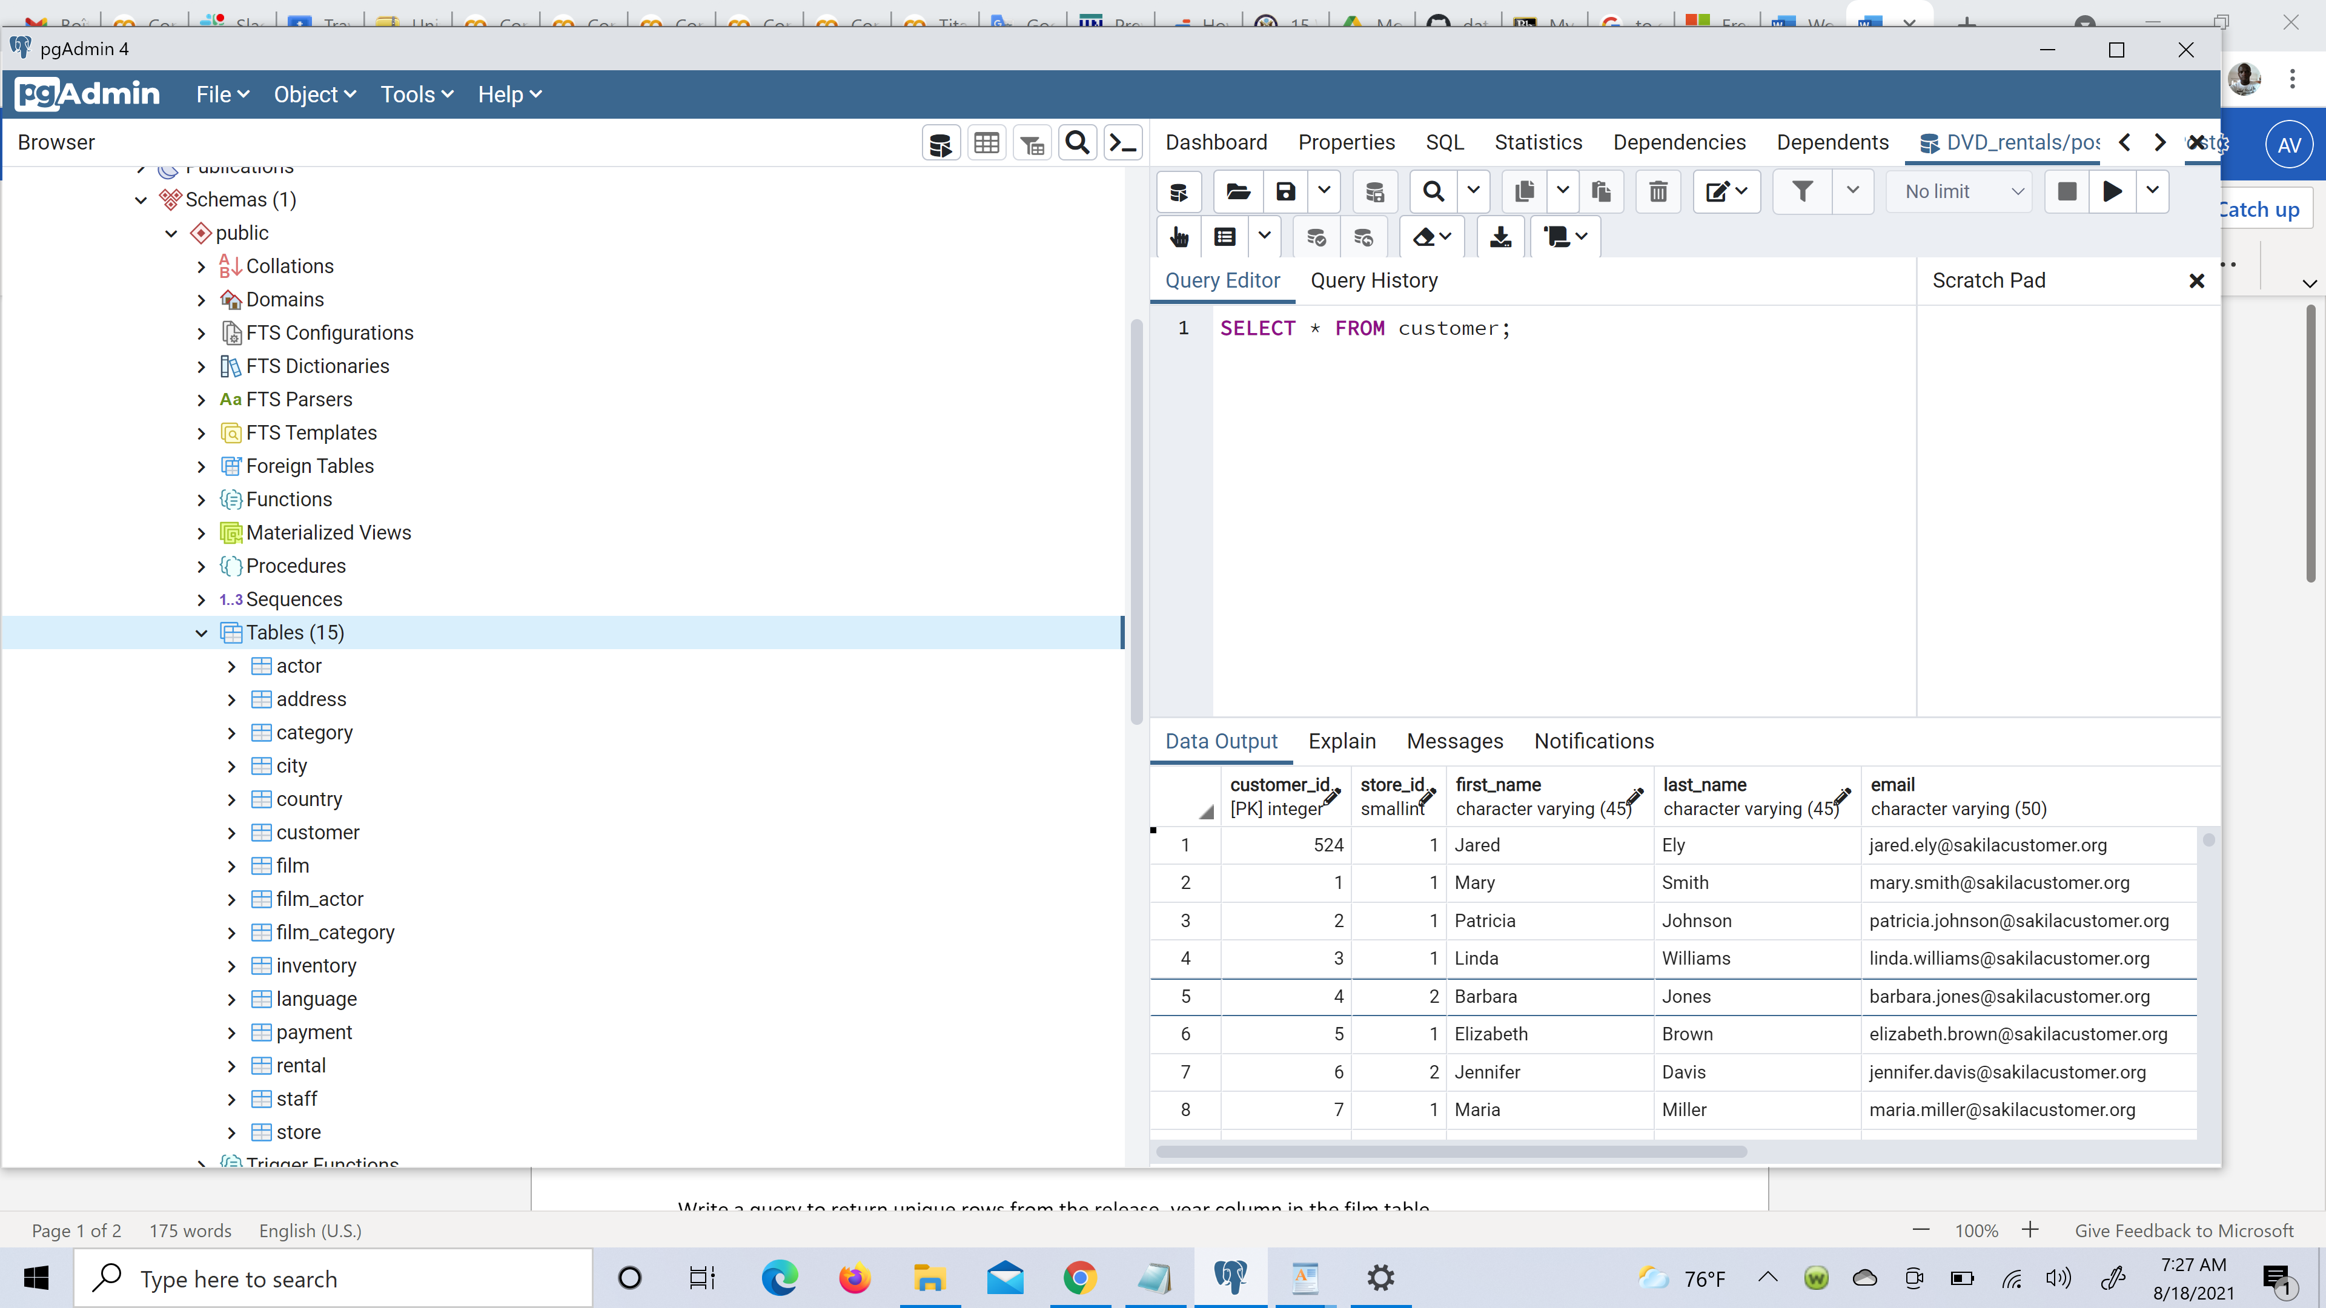

Write a query to select first name, last name, and email from the customer table

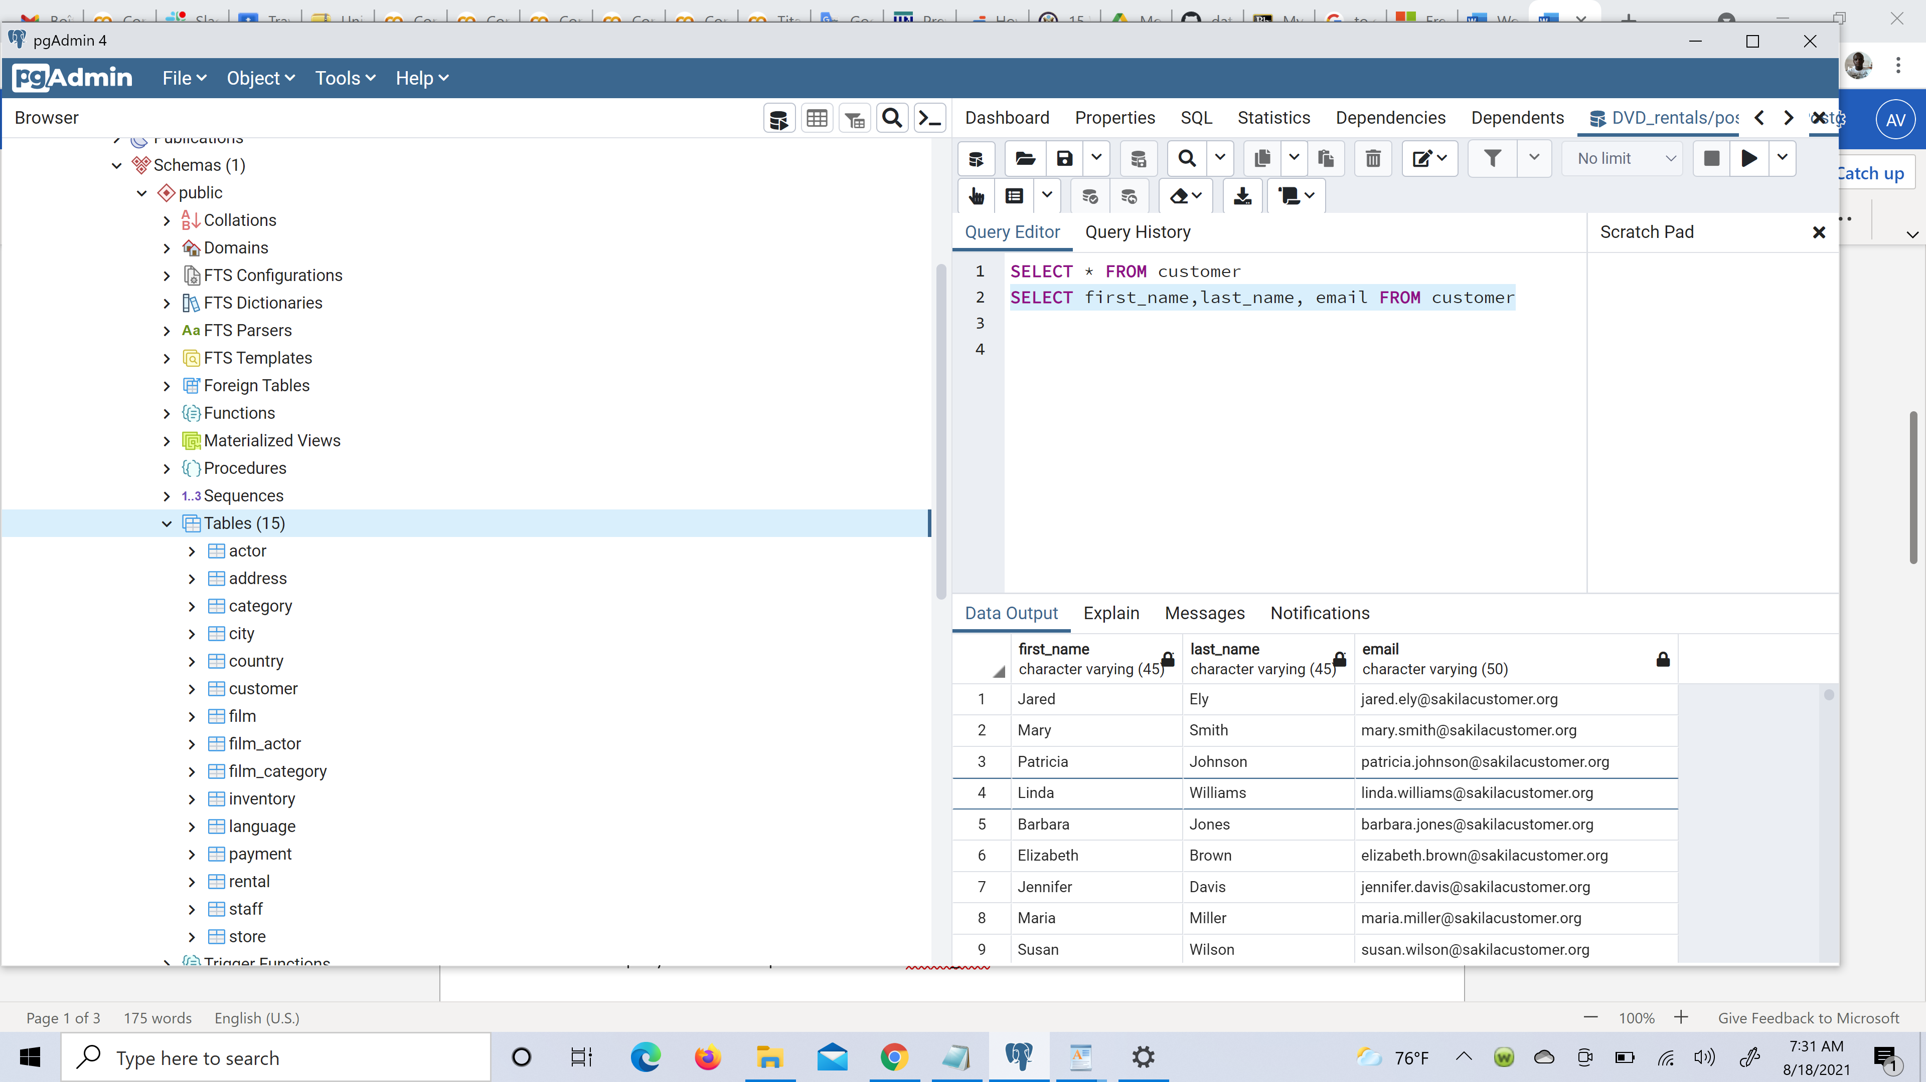

Write a query to return all rows and columns from the film table.

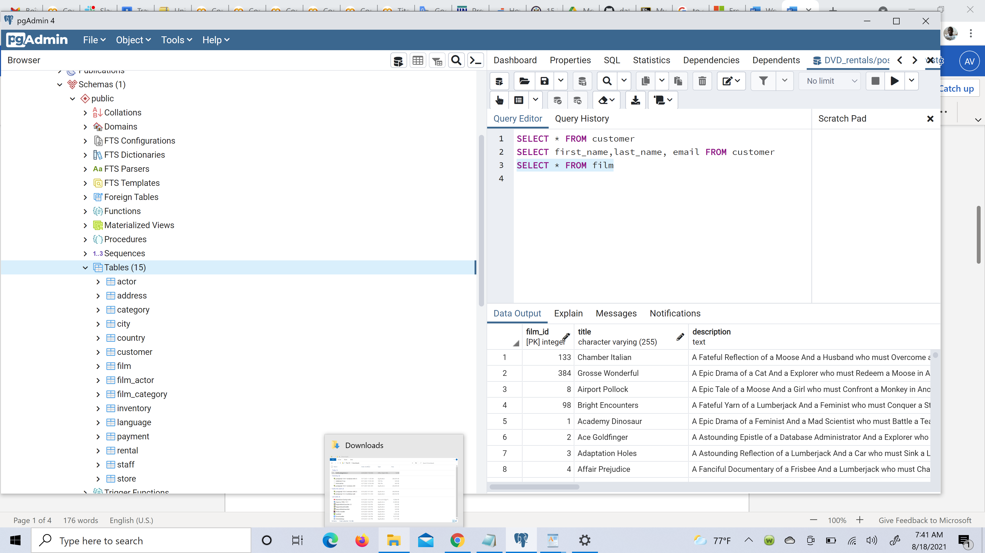

Write a query to return unique rows from the release year column in the film table.

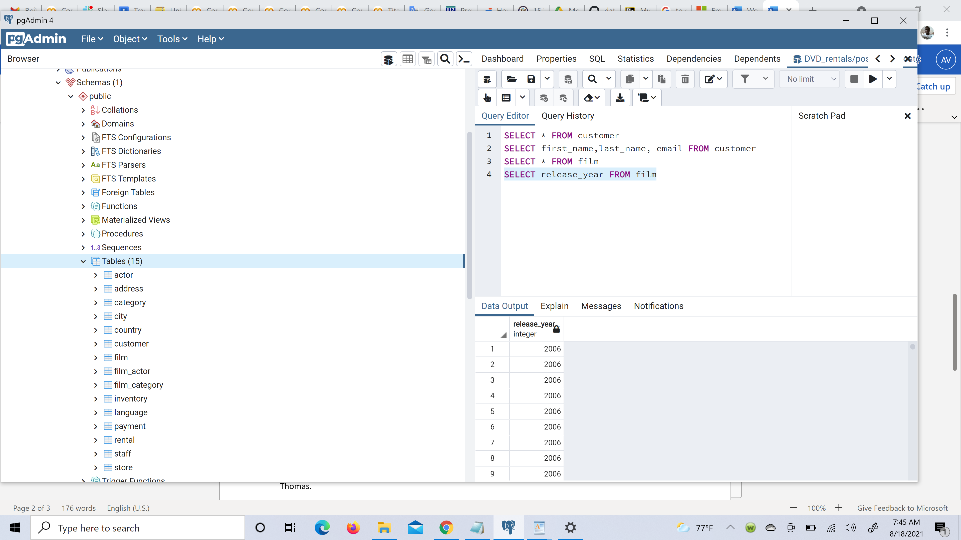

Write a query to return unique rows from the rental_rate column in the film table.

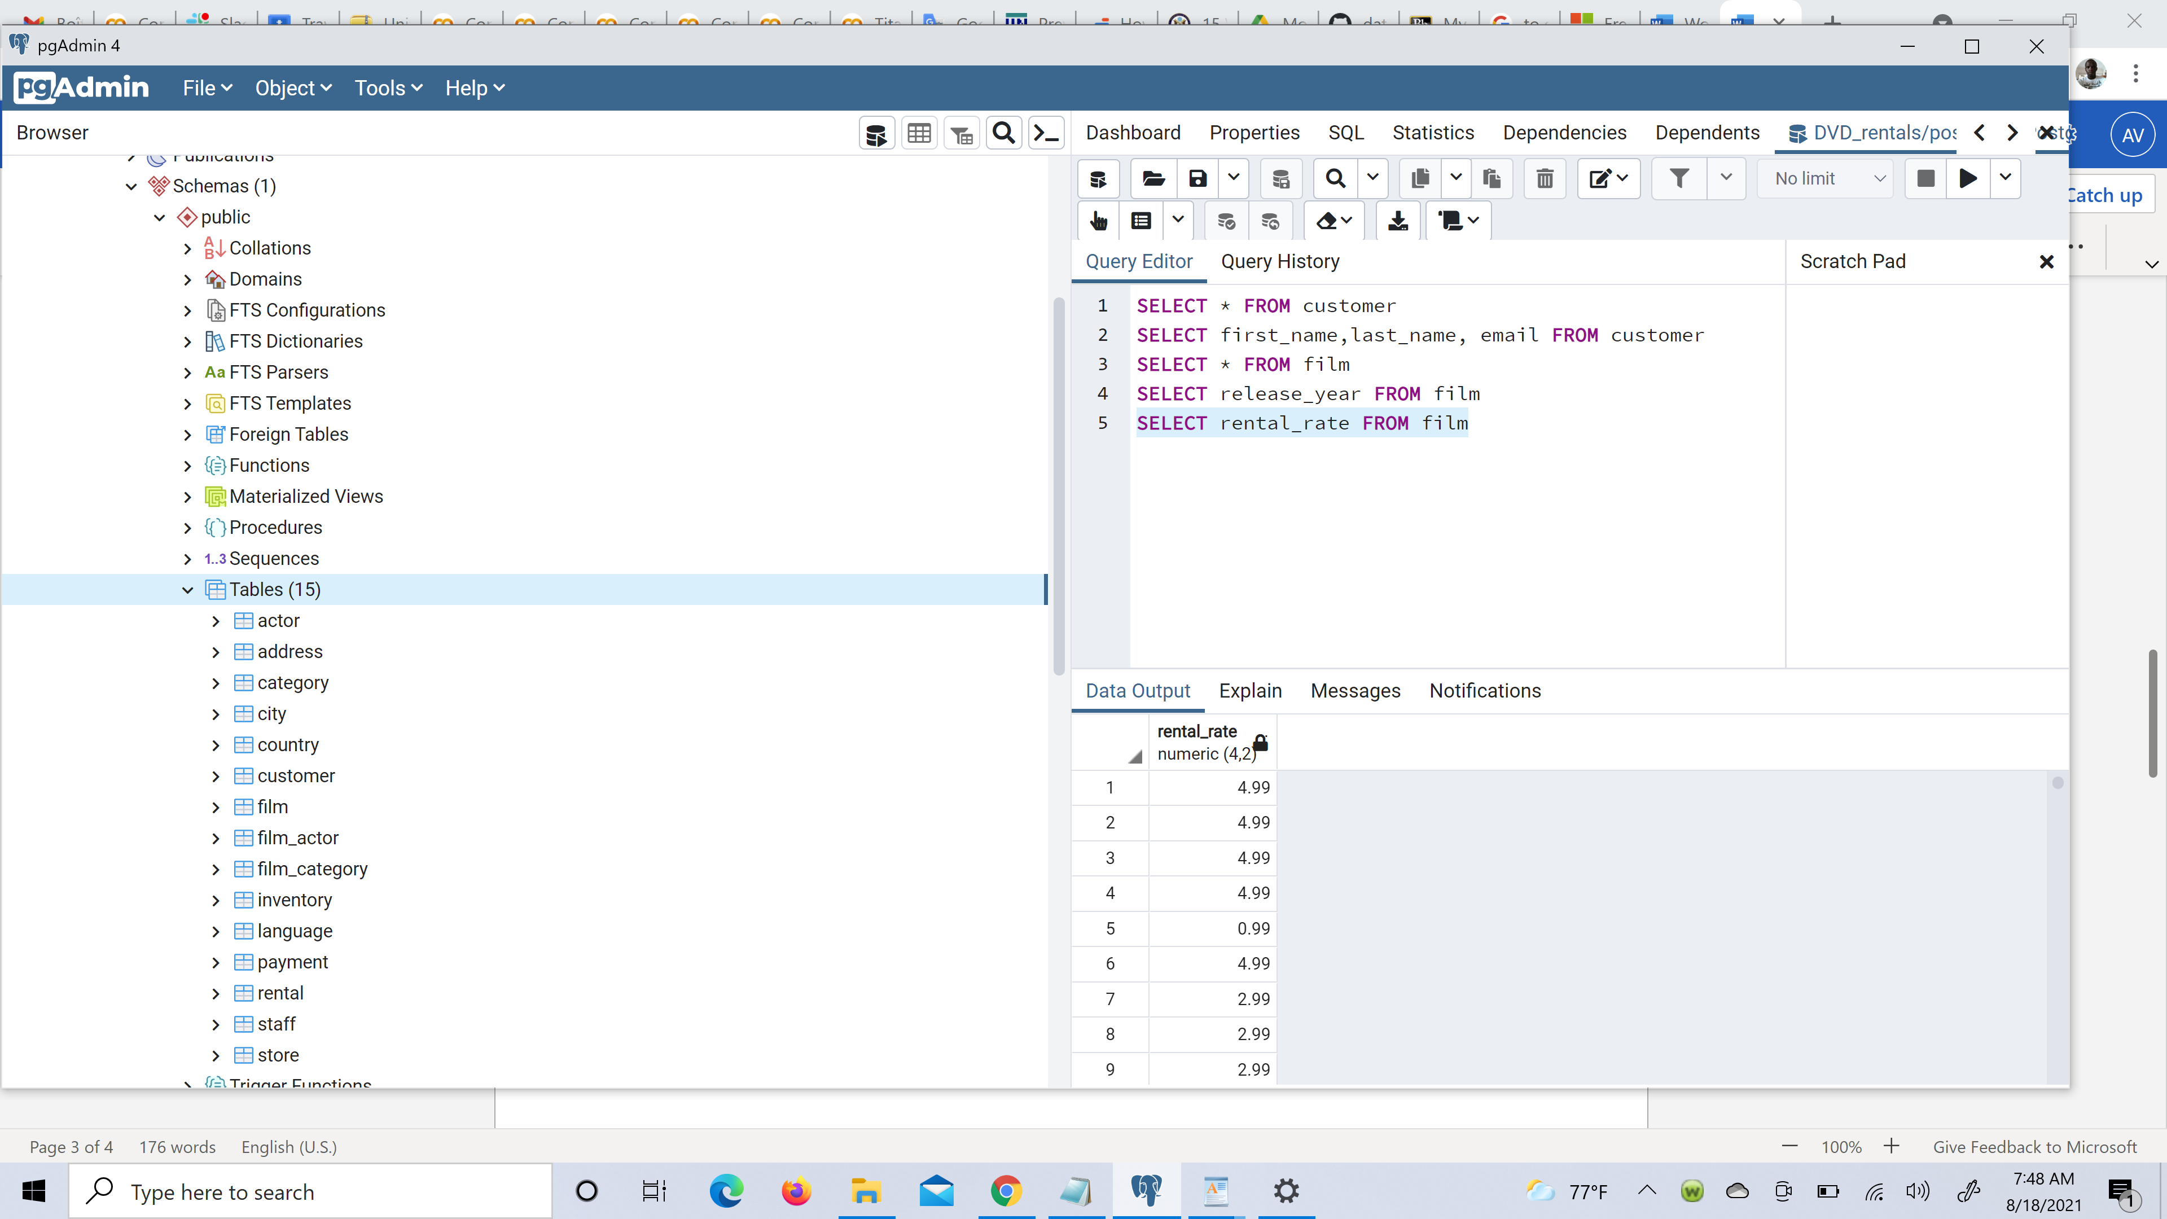

A customer left us some feedback about our store. Write a query to find her email address – for Nancy Thomas.

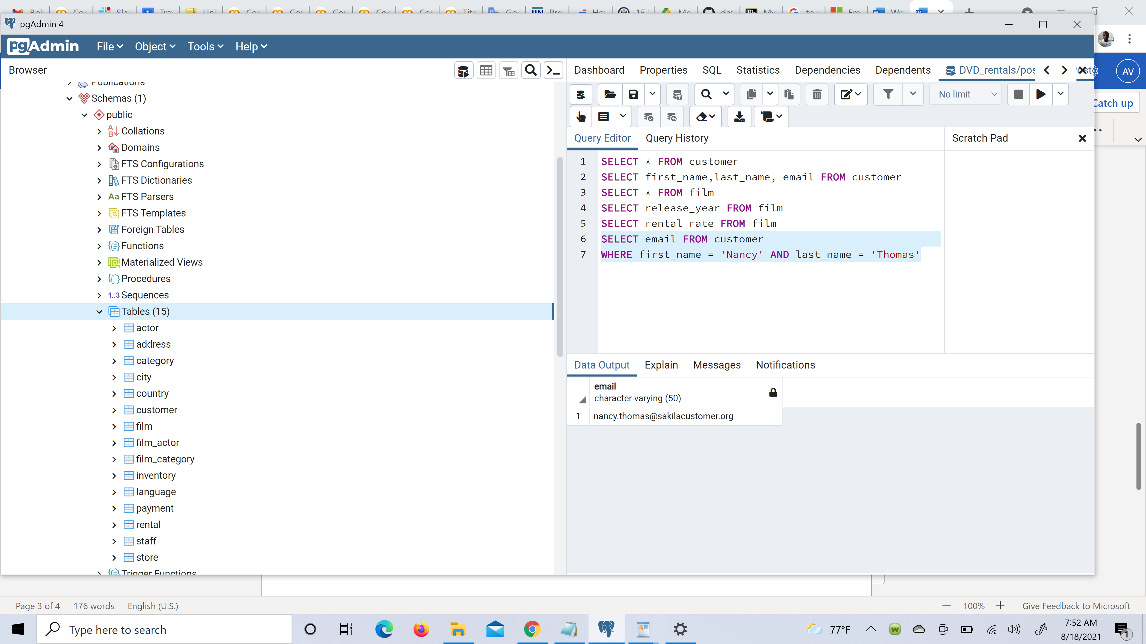

We’re trying to find a customer located at a certain address ‘259 Ipoh Drive’ – can you find their phone number?

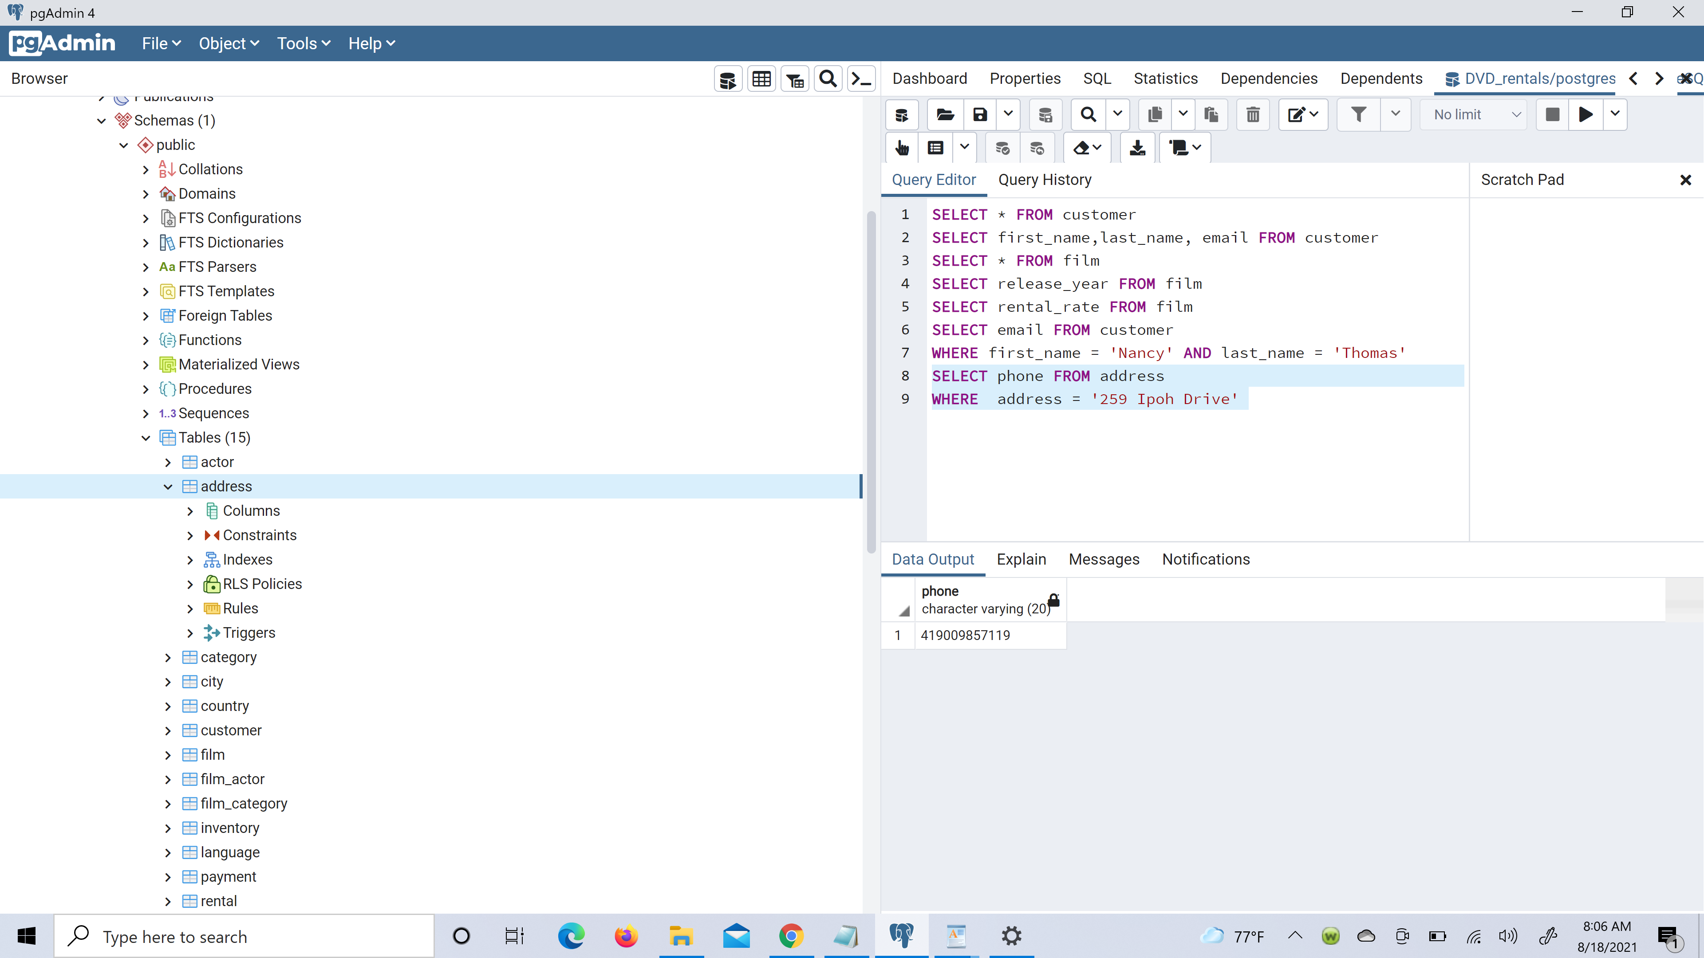

Write a query from the customer table, where store id is 1 and address id is greater than 150.

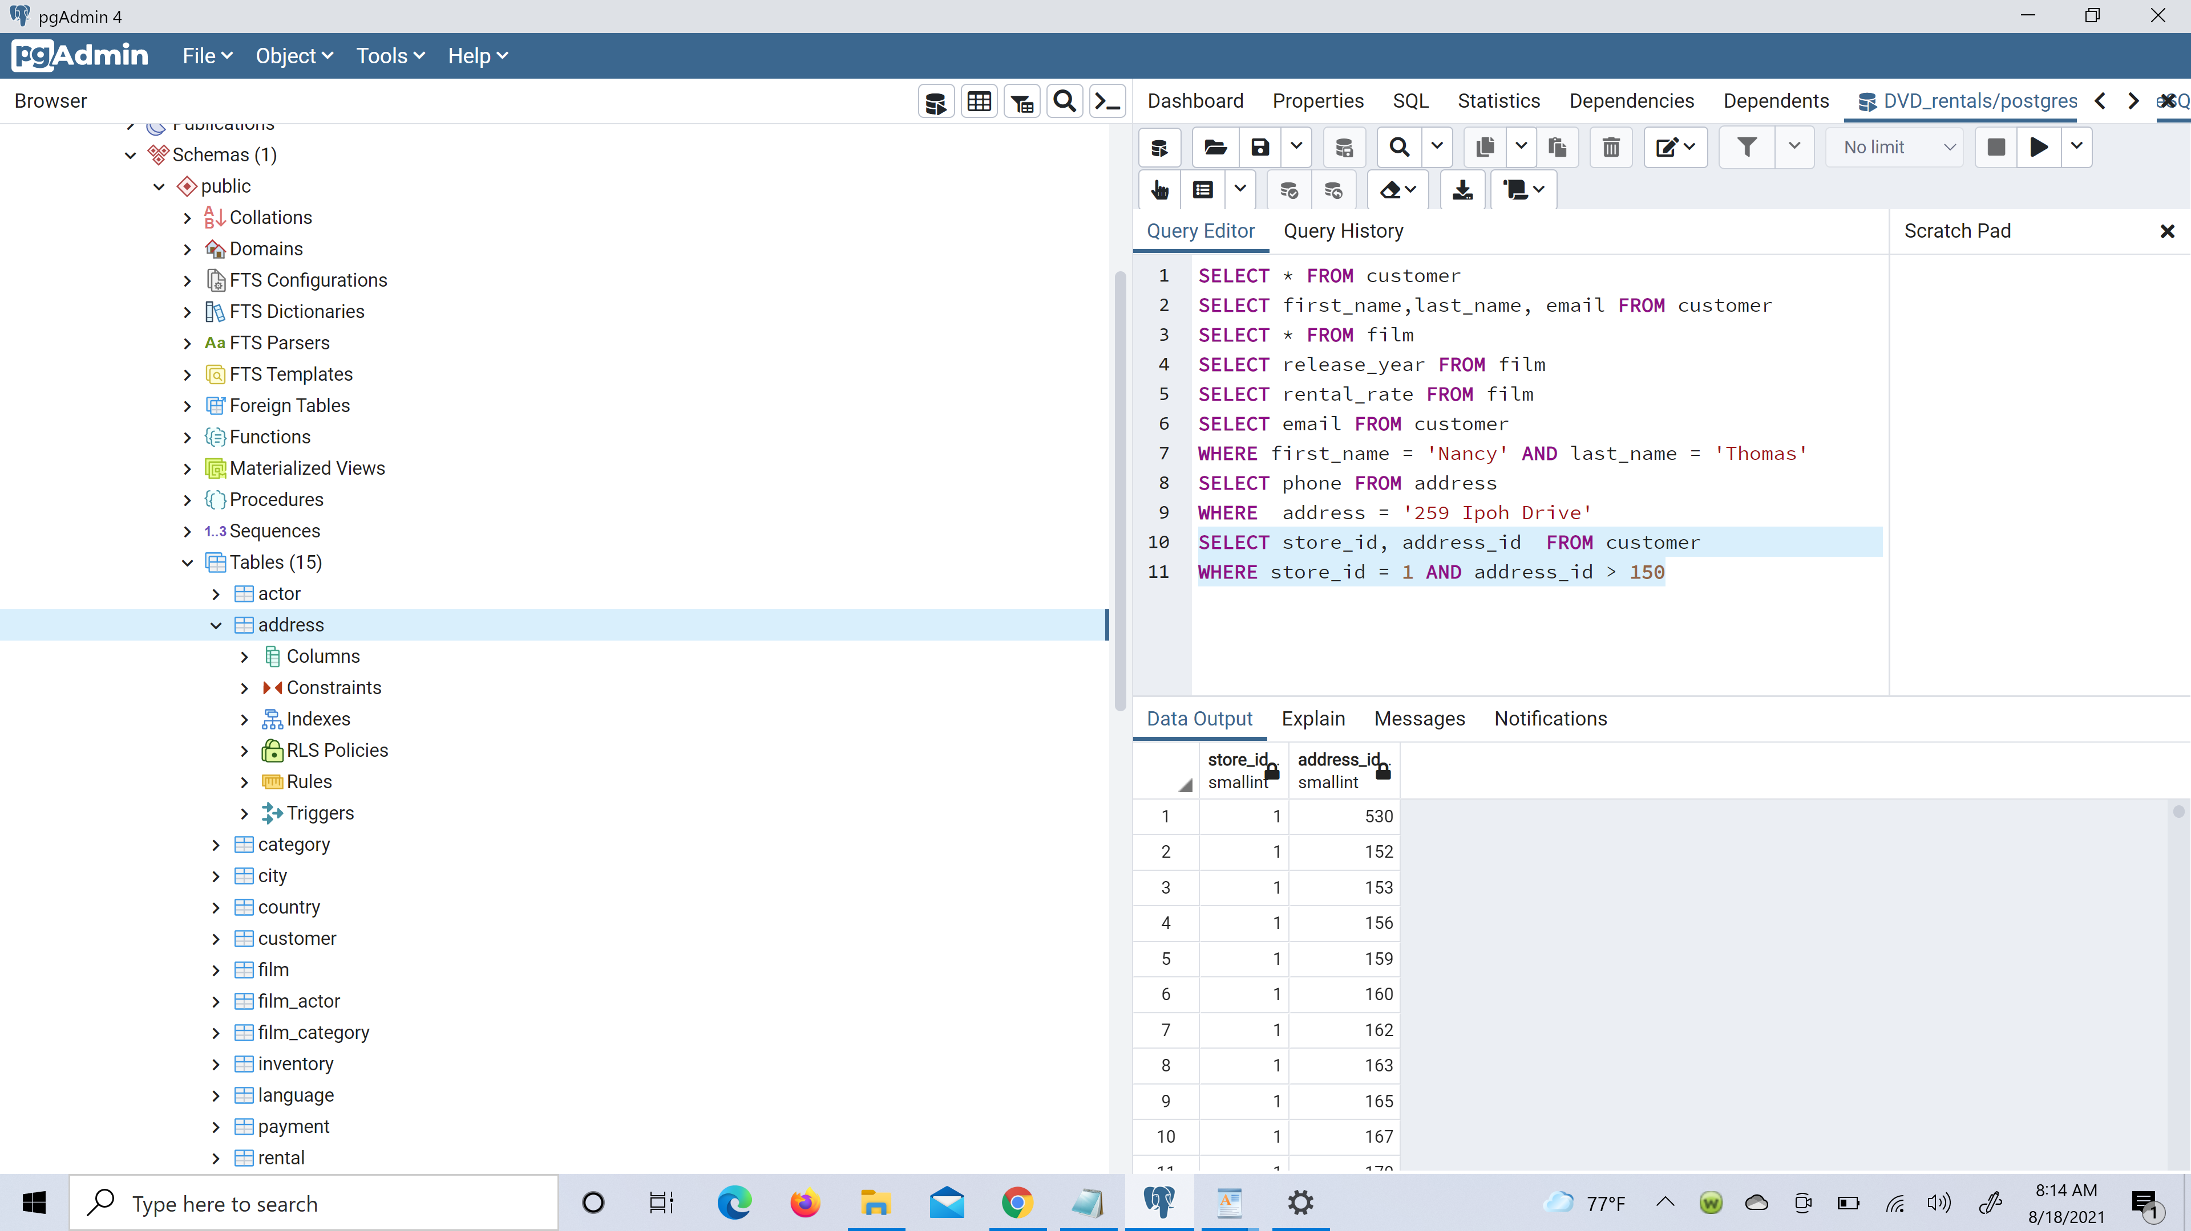

Write a query from the payment table where the amount is either 4.99 or 1.99. 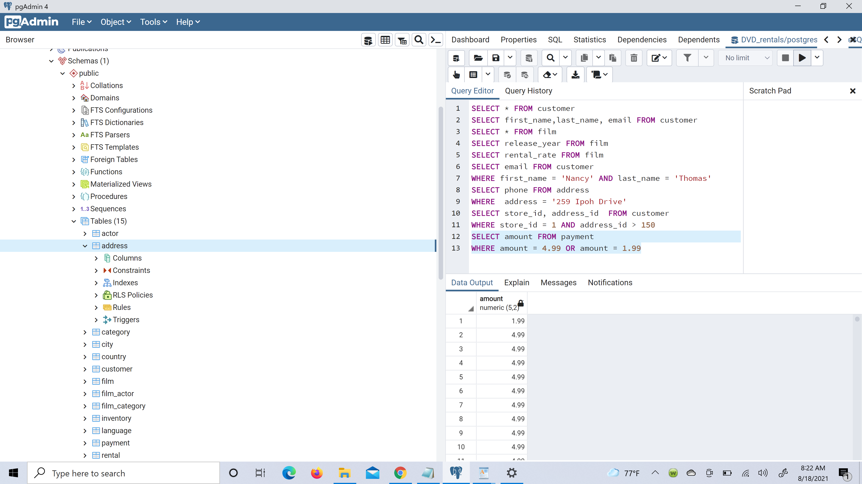

Write a query to return a list of transitions from the payment table where the amount is greater than 5.

